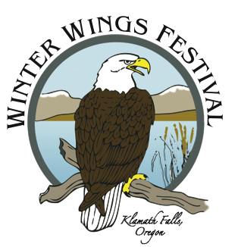

2023 Sponsor Levels and Benefits

Recognition | Title Sponsor  $5000 or more in cash | Bald Eagle Level  ($2500 -$4999 in cash or $2500 or more in-kind donations) | Golden Eagle Level  ($1000 - 2499 in cash or  in-kind donations) | Tundra Swan Level  ($500 - 999 in cash or in-kind donations) | Snow Goose Level  ($250 - 499 in cash or in-kind donations) | Peregrine Falcon Level  ($25 - 249 in cash or in-kind donations)
Special banner and signage recognition at the Oregon Institute of Technology campus, plus acknowledgement at any other receptions and the two keynotes. | ✓
Prominent recognition in a Festival press release if commitment received by Dec. 31, 2022 | ✓
Special field trip or workshop for up to 15 employees (birdwatching, attracting birds to your yard, kayaking, etc.) in spring or summer following the festival | ✓
Two complimentary keynotes and receptions for two | ✓
Special name badge recognition at festival | ✓
One year complimentary membership in Klamath Basin Audubon for up to 5 individuals | ✓
Prominent sponsor logo on the landing page of WWF website and on the KBAS website | ✓ | ✓
Prominent display of recognition at the Festival site. | ✓ | ✓ | ✓
Recognition | Title Sponsor  $5000 or more in cash | Bald Eagle Level  ($2500 -4999 in cash or $2500 or more in-kind donations) | Golden Eagle Level  ($1000 - 2499 in cash or  in-kind donations) | Tundra Swan Level  ($500 - 999 in cash or in-kind donations) | Snow Goose Level  ($250 - 499 in cash or in-kind donations) | Peregrine Falcon Level  ($25 - 249 in cash or in-kind donations)
Business name appears on Festival poster and along with logo for Title Sponsor | ✓ | ✓ | ✓ | ✓
Festival website links to your business on the Festival sponsor page on www.WinterWingsFest.org | ✓ | ✓ | ✓ | ✓ | ✓ | ✓
Opportunity to underwrite and have a sign displayed at one birding tour, workshop, presentation or other reception as the event underwriter | ✓ | ✓ | ✓ | ✓ | ✓
Complimentary sales or display table at the Festival | ✓ 2 tables | ✓ 2 tables | ✓ 1 table | ✓ 1 table
Host hotels will get exclusive recognition on website travel information and on social media releases |  |  | ✓ | ✓

Payment Instructions

Make checks payable to:

Klamath Basin Audubon Society
PO Box 354
Klamath Falls, OR 97601

Sponsorship Questions

Submit questions to info@WinterWingsFest.org or leave message at 877-541-2473.

The Klamath Basin Audubon Society which produces the festival is a 501c3 nonprofit organization. Your sponsorship support is tax-deductible to the extent provided by law.

Updated: July 24, 2022

